🔥 Day 21 — Full DNS Troubleshooting Challenge

🎯 Goal
👉 You will break your system
👉 Then debug it using everything you learned (Day 15–20)

⚠️ Step 1 — Break the System (Multiple Issues)
Do ALL of these:

1. Break DNS
sudo vi /etc/resolv.conf
Put:
nameserver 192.168.1.200

2. Add Wrong Hosts Entry
sudo vi /etc/hosts
Add:
1.2.3.4 google.com

3. (Optional but powerful) Restart network
sudo systemctl restart NetworkManager
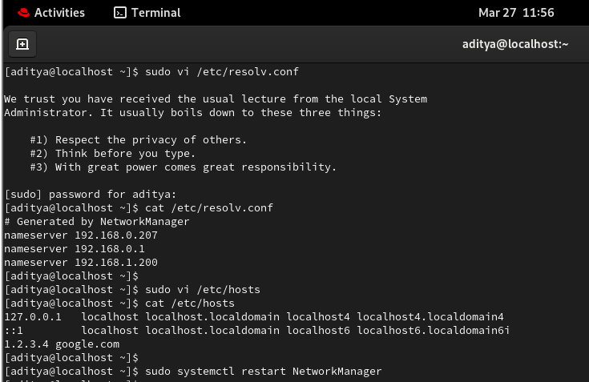

🧪 Step 2 — Observe Problem
Now test:
ping google.com
👉 It will fail or behave weird
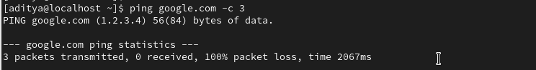

🧠 Step 3 — YOU DEBUG (Don’t Jump)
Follow this exact order:

Step 1: Network Check
ping 8.8.8.8
✔ If works → network OK

Step 2: DNS Check
ping google.com
❌ fails → DNS issue

Step 3: Check hosts file
cat /etc/hosts
👉 You should catch:
1.2.3.4 google.com
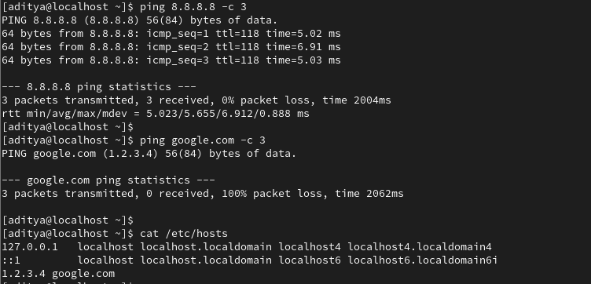

Step 4: Remove it
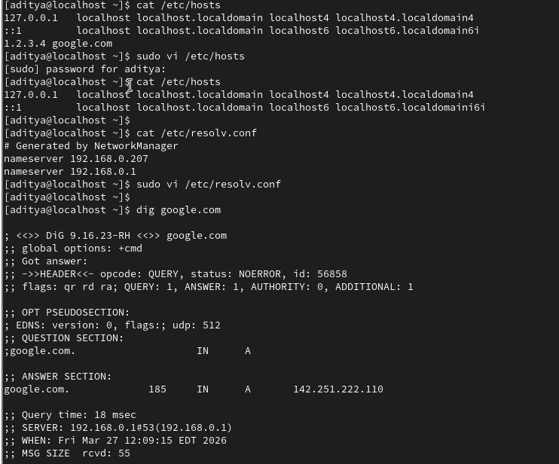
Step 5: Check DNS config
cat /etc/resolv.conf
👉 You’ll see wrong DNSStep 6: Fix it
nameserver 8.8.8.8

Step 7: Verify using dig
dig google.com
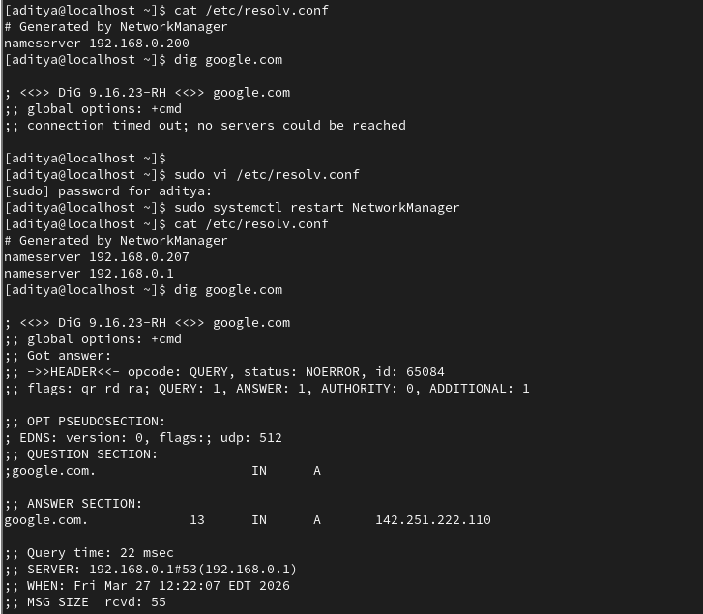

Step 8: Final test
ping google.com
✔ Should work
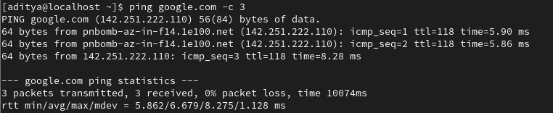

🧠 What Just Happened (Important)
You had multiple issues at once:
1. /etc/hosts override
2. Wrong DNS server
👉 This is REAL WORLD
Problems are never single-cause

🔥 What You Must Write Today

Full Debug Flow (Final Version)
1. Check connectivity (ping IP)
2. Check domain resolution
3. Check /etc/hosts
4. Check /etc/resolv.conf
5. Use nslookup/dig
6. Fix step-by-step

Key Insight
Multiple issues can exist at the same time.
Fixing one may not solve the problem.

Biggest Learning
Do not assume.
Always verify layer by layer.

✅ Expected Output (Day 21)
You should have:
✔ Broken system intentionally
✔ Identified multiple issues
✔ Fixed hosts + DNS
✔ Verified using dig + ping
✔ Written full troubleshooting flow

📓 Day 21: Full DNS Troubleshooting
Focus: Solving multi-layered network failures.
🛠️ The "Broken" Scenario
- Local Poisoning: /etc/hosts was modified to point google.com to a fake IP (1.2.3.4) (p. 1).
- DNS Black-holing: /etc/resolv.conf was set to a non-existent nameserver (192.168.1.200) (p. 1).
- The Result: Even with physical internet access, domains were unreachable or resolved incorrectly (pp. 2, 4).
🔍 The Golden Debugging Flow
Always follow this hierarchy to save time:
- Network Check: ping 8.8.8.8
  - If this works, your physical connection and routing are fine (p. 3).
- Local Override Check: cat /etc/hosts
  - Check for manual entries that "lie" to the system (p. 3).
- DNS Config Check: cat /etc/resolv.conf
  - Ensure nameservers are valid and reachable (p. 5).
- Deep Verification: dig <domain>
  - Confirms which server is responding and what data it provides (p. 6).
💡 Key Lessons Learned
- The Hierarchy of Truth: Linux checks /etc/hosts before it asks a DNS server. If a domain is listed there, the DNS server is ignored (p. 7).
- NetworkManager Overwrites: Restarting the network often resets /etc/resolv.conf. Manual changes there are temporary unless configured via the service (p. 2).
- Layered Failures: Fixing one issue (like the hosts file) might not restore service if a second issue (like a bad nameserver) exists (p. 8).
✅ Verification Complete
- Broken system intentionally? Yes (p. 2).
- Identified multiple issues? Yes (pp. 4-5).
- Fixed and Verified? Yes, confirmed with dig and successful ping (pp. 6-7).

